SQL Assignment – 12
Using the operators IN, ANY, and ALL.
D2_83822_Rohit

1) Write a query that selects all customers whose ratings are equal to or greater than ANY of Serres’.

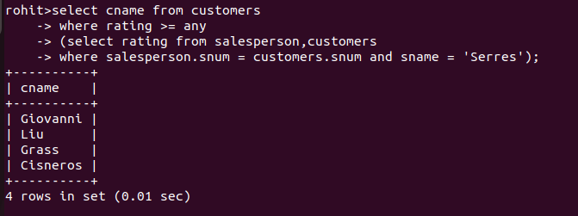

2) Write a query using ANY or ALL that will find all salespeople who have no customers located in their city.

3) Write a query that selects all orders for amounts greater than any for the customers in London.

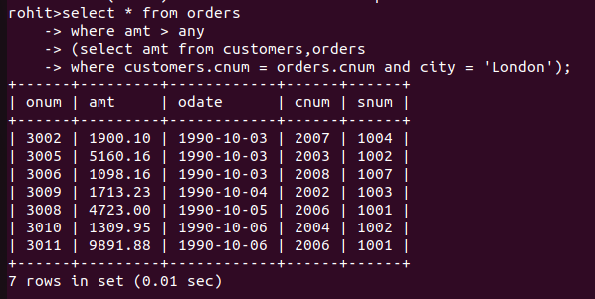

4) Write the above query using MIN or MAX.

